Simulation # 10

**BJT Characteristics and Analysis**



**Electronic circuits and devices simulation laboratory (EE 2701)**

Department of Electrical Engineering, NIT Rourkela



|  |  |
| --- | --- |
| *BJT Characteristics and analysis* | 1 |

**Aim of the Expt**.:To simulate BJT Characteristics and analysis

**Objective**:

1. Plot the input characteristics and output characteristics using IV analysis instrument and DC parameter sweep method
2. DC Circuit analysis for Colpitts Oscillator
3. AC analysis / frequency response of the BJT based amplifier in CE mode

**Theory:**

Multisim can simulate circuits with the three types of transistors. They are the Bipolar Junction Transistor (BJT), the Metal-Oxide-Semiconductor Field Effect Transistor (MOSFET), and the Junction Field Effect Transistor (JFET).

In addition, Multisim also includes the Unijunction transistor (UJT), power MOS transistor, and the Darlington transistor array. For the PNP BJT, channel P MOSFET, and channel P JFET, the arrow is in the opposite direction. Every transistor name starts with the letter Q and it is numbered sequentially, thus the first transistor is Q1, the second one is Q2, and so on. Any transistor is available by clicking on the transistor group icon in the components toolbar.

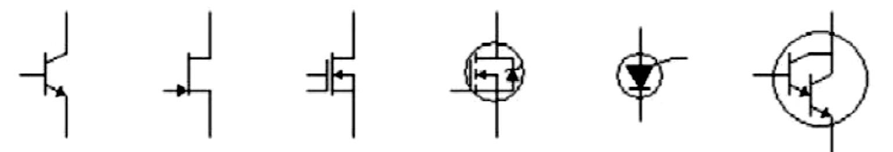

*Figure 1 Transistor symbols in Multisim. (a) BJT npn; (b) Channel n JFET; (c) Channel n MOSFET (d) Power MOSFET;*

*(e) Unijunction transistor; (f) Darlington pair;*

**BJT Characteristics:** Basically, a BJT is composed by two back-to-back diodes, one of them, thebase emitter-diode, is forward biased and the other one, the base-collector diode, is reverse biased. In our circuit, the voltage source V1 forward biases the base-emitter diode. The voltage drop across the base emitter diode is approximately 0.7 V for silicon transistors and 0.2 V for germanium ones. In order to plot the characteristic curves, we use the I-V plotter from the Instruments toolbar. This instrument plots the collector current vs. collector-emitter voltage with base current as a parameter.

**DC Operating Point Analysis** calculates the behaviour of a circuit when a DC voltage or current isapplied to it. The result of this analysis is generally referred as the bias point or quiescent point (Q-point). In most cases, the results of the DC Operating Point Analysis are intermediate values for further analysis. For example, in AC analysis, the DC operating point is first calculated to obtain linear, small-signal models for all nonlinear components (such a diodes and transistors).

Assumptions: AC sources are zeroed out, capacitors are open, inductors are shorted, digital components are treated as a large resistor to ground.

**AC Analysis** is used to calculate the small-signal response of a circuit. In AC Analysis, the DCoperating point is first calculated to obtain linear, small-signal models for all nonlinear components.



|  |  |
| --- | --- |
| *BJT Characteristics and analysis* | 2 |

Then, the equivalent circuit is analysed from a start to a stop frequency. The result of an **AC Analysis** is displayed in two parts: gain versus frequency and phase versus frequency.

Multisim performs **AC Analysis** using the following process:

1. DC operating Point Analysis is performed to obtain the small-signal models.
2. A complex matrix, containing both real and imaginary components are created. Multisim constructs this matrix using the following approach:
   * DC sources are given zero values.
   * AC sources, capacitors, and inductors are represented by their AC models.
   * Nonlinear components are represented by linear AC small-signal models, derived from the DC operating point solution.
   * All input sources are considered to be sinusoidal, their frequency is ignored.
   * If the Function Generator is set to a square or triangular waveform, it will automatically switch internally to a sinusoidal waveform.
3. AC circuit response is calculated as a function of frequency.

**Assumptions:** The analysis is applied to an analog circuit, small-signal. Digital components aretreated as large resistances to ground.

**Procedure:**

**A. BJT output characteristics (Using IV analysis instrument):**

1. Connect the circuit as per the circuit diagram shown in Figure 2.
2. To obtain the characteristic curves, use the Run icon and open the I-V Analysis instrument to observe the curves**.** Figure 3 shows the cursor positioned at the position of Vce, a collector current Ic, and a base current corresponding to the selected curve.
3. The Sim_Param button is used to specify parameters for the collector emitter voltage Vce and the base current Ib, shown by Figure 4.
4. Format and save the characteristics from Grapher view.

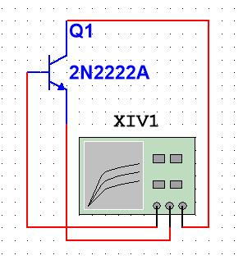

*Figure 2 Setup for BJT output Characteristics*



|  |  |
| --- | --- |
| *BJT Characteristics and analysis* | 3 |

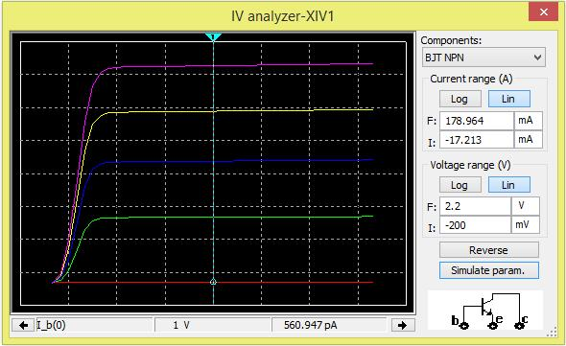

*Figure 3 I-V Analysis instrument*

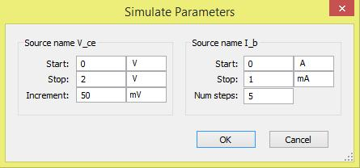

*Figure 4 Simulation parameters for the IV characteristics*

**B. BJT input and output characteristics (Using DC Sweep):**

1. For obtaining input and output characteristics, connect the circuit as per the circuit diagram shown in Figure 5.
2. Simulate the input characteristics using DC sweep analysis using parameters shown in Figure 6.

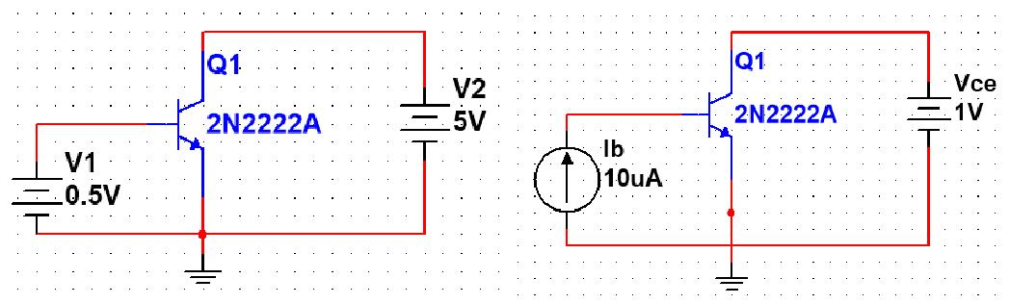

*Figure 5 Circuit for BJT input and output characteristics*



|  |  |
| --- | --- |
| *BJT Characteristics and analysis* | 4 |

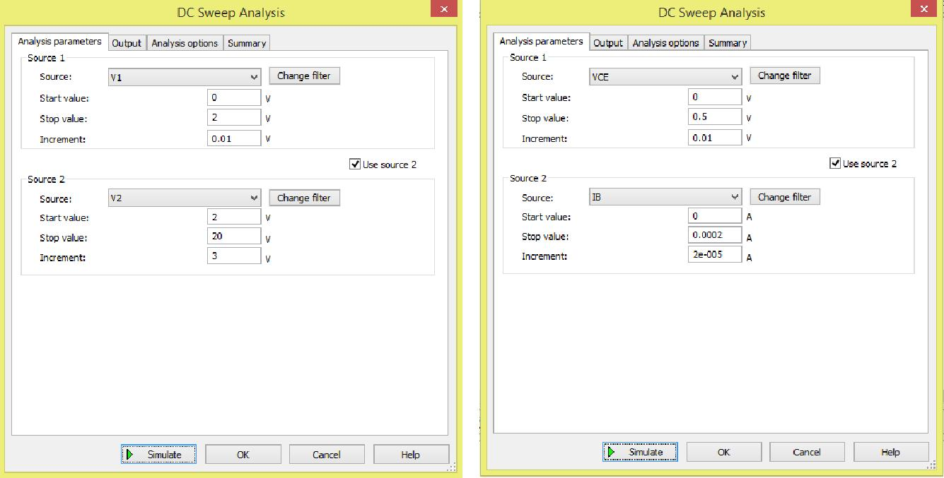

*Figure 6 Settings for DC sweep analysis for input and output characteristics of BJT in common emitter mode*

**DC Operating Point Analysis**

1. In this example, we calculate the DC value generated at the collector, VC, of the Colpitts oscillator circuit shown in Figure 7.
2. Select Simulate » Analyses » DC Operating Point.
3. Select the Variables in circuit list, select All variables from the drop-down list, and then highlight V(vc) from the list.
4. Click the Add button to move the variable to the right side under Selected variables for analysis,
5. Click Simulate to run the DC Operating Point Analysis. The Grapher View window opens and presents the result for V(vc):

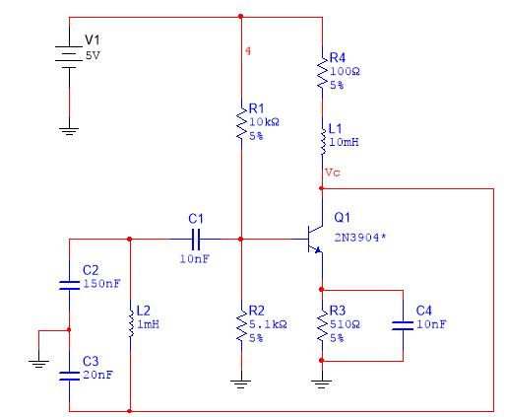

*Figure 7 Colpitts Oscillator DC Operating Point Analysis*



|  |  |
| --- | --- |
| *BJT Characteristics and analysis* | 5 |

1. **AC Operating Point Analysis** 
   1. Simulate the response of the CE amplifier shown in Figure 8.
   2. Consider 15V as VCC.
   3. Run AC analysis for the same in the 1 Hz to 10 GHz range.

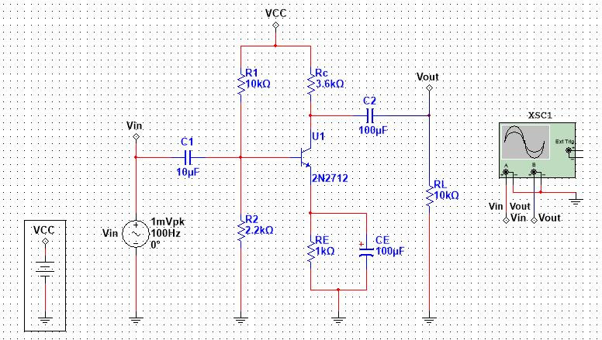

*Figure 8 BJT CE Amplifier for AC operating point analysis*

**Questions:**

1. Verify the DC operating point analysis carried for Colpitts oscillator (Calculate the value of collector Voltage Vc).
2. Calculate % change in β value between any two output characteristics.
3. Calculate the bandwidth of the CE amplifier. Discuss the effect of all three capacitors on the frequency response of the amplifier.



|  |  |
| --- | --- |
|  |  |

*BJT Characteristics and analysis*